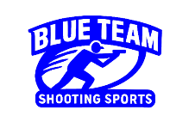Stage 2 - Do you need a count?
COURSE DESIGNER: Ike Starnes
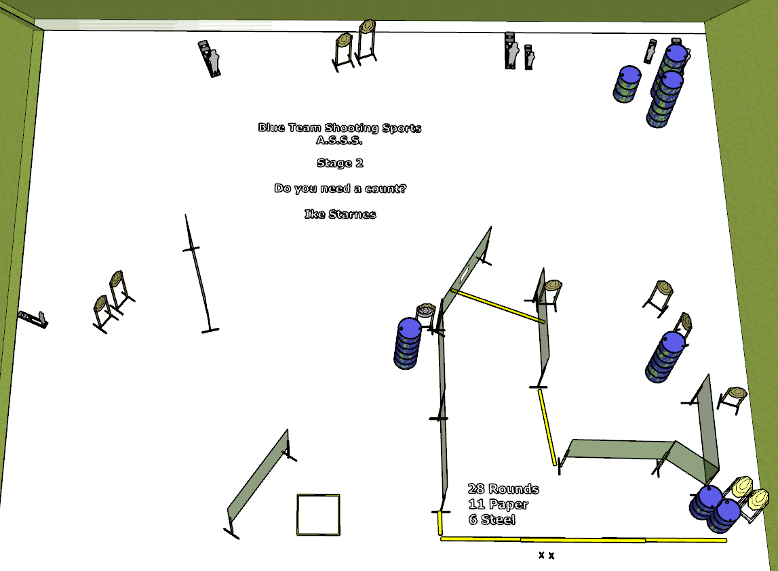

Written Stage Briefing:
Stage 2 – Do you need a count? is a 28 round, 140 point, Comstock course. There are 11 cardboard targets and 6 steel targets. The best 2 hits per cardboard target will be scored. The steel must fall to score.
Start position Both feet on the Shooting Sports Innovations Xs.
Handgun: Loaded and holstered, wrists below belt
PCC: Loaded, stock touching belt
On the audible start signal, engage targets from within the shooting area.

